THE STAFF PERCEPTION OF THE DISRUPTIVE PATIENT BEHAVIOR (SPDPB) SCALE REQUEST FORM

The Staff Perception of the Disruptive Patient Behavior (SPDPB) Scale is intended to measure staff perceptions of 6 components of patient disruptive behavior in the professional clinical practice environment. The psychometric properties of this scale are published the Journal of Nursing Administration (Lipkis-Orlando, Carroll, D., Duffy, M., Weis, A., Jones, D. (2013).

You may use the SPDPB Scale for research or evaluation projects provided the scale is not altered in any manner and the authors are acknowledged in all reports or publications. Upon submission of this form, you will receive a complete SPDPB packet outlining the items specifics and scoring criteria for the SPDPB Scale.

Title: First Name: Last Name:

Credentials: Role:

Principal Investigator Institution:

Department:

Address Line 1:

Address Line 2:

City:

State/Province/Region:

Zip/Postal Code:
Country:
Email:

Phone Number Work:

Phone Number Mobile:

How did you hear about the SPDPB?

Please explain the intended use of the SPDPB (population to be surveyed; study goals and outcomes)

Single Site: Multi-site:

Do you anticipate need for translation of the SPDPB (if so what language(s))?

We appreciate your interest in this research work. We will follow-up in approximately three months to learn more about your experiences to continue to improve the instrument. In the meantime, do not hesitate to contact us. We ask that all communications concerning the use of the SPDPB be sent to Stacianne Goodridge, The Yvonne L. Munn Center for Nursing Research, Massachusetts General Hospital, 125 Nashua Street, Boston, MA 02114 USA or via email at sgoodridge@partners.org. We wish you well in your research endeavors and ask that you keep us apprised of your successes stemming from this work.

Sincerely,

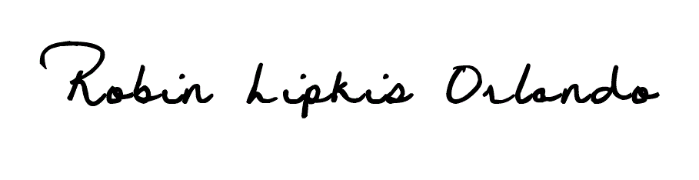

- Permission to use this tool granted by: Robin Lipkis Orlando

Reference: Lipkis-Orlando, Carroll, D., Duffy, M., Weis, A., Jones, D. (2013). Psychometric Evaluation of the Staff Perception of the Disruptive Patient Behavior Scale. JONA, Volume 46, Number 5, p. 250-256.

