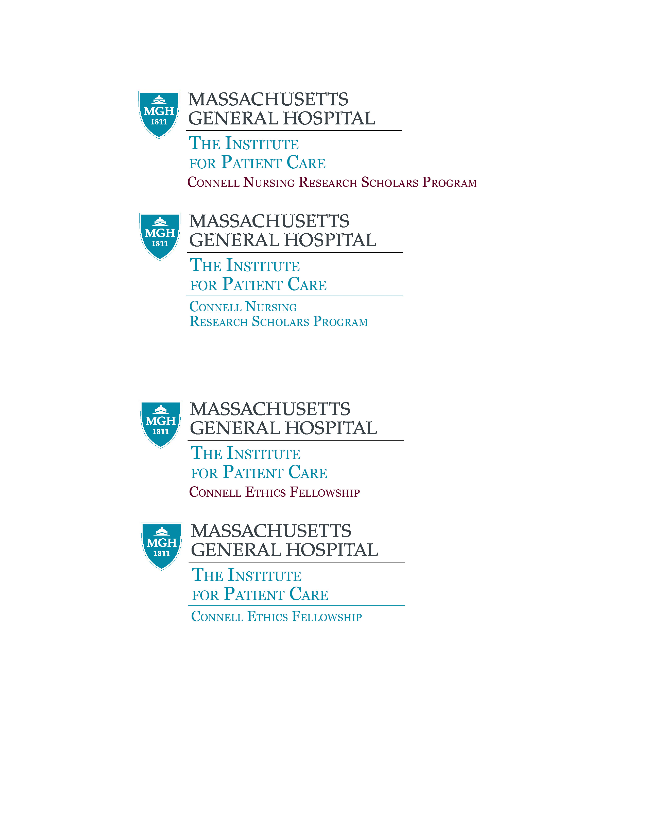

Connell Research Scholar Application
*Attach a CV with Application

1. Date of Submission: ___________

Name

Email Address

Current Position

Unit/Patient Care Area

Applicant Signature

Manager’s Name and Signature

2. Applicant’s Research Interest

Area of Research:
Early Career/Advanced/Mid Career Research Scholar

Describe the relevance of work to strategic goals of the MGH/PCS organization, and the Connell Nursing Research Scholars Program

3. Previous and/or Current Funding
Include all funding sources: Federal, Private, Foundation, Specialty Association, and Institutional grants and contract support (insert additional rows if needed).

GRANT TITLE  (Do not Abbreviate) | FUNDING SOURCE | ROLE IN PROJECT/  PROJECT % of EFFORT | INCLUSIVE DATES | AMOUNT OF GRANT FUNDING

4. Additional Information

Publications:

(Highlight in those articles (refereed and non-refereed) that support research interest(s).

Awards:

(highlight those Awards that support your Connell Nursing Research Scholar Application)

5. Proposed Goals for the Connell Nursing Research Scholars Program:
Please review the guidelines attached. Please provide a 3-5 page summary that includes:
    - A brief study background including literature and knowledge gap
    - Statement of your short- and long-term research goals.
    - Plans to achieve these goals during your CNR Award timeframe.
    - A brief discussion of the significance of your proposed research investigation on nursing science and patient care outcomes.
    - How the fellowship will further your program of research and help achieve your research goals?
    - Discuss impact of your research. How will the CNRS Fellowship help to further PCS and IOM goals to promote patient/family-centric, safe, quality care?

6. Timeline

a. Description of the timeline for completion of the fellowship, with milestones indicated to include progress toward submission of grant application over the time as a Connell research Scholar’s application for funding period

b. Progress Reporting: Connell Nursing Scholars will submit progress reports at designated intervals following the initial appointment. A summary report of your Connell Nursing Research Scholar will be requested at the completion of the experience.

c. Included in the Timeline:

- Mentor Meetings: Proposed frequency
- Search for potential funding sources
- Proposed grant outline
- Timeline for grant submission
- Seminars Meetings (monthly)
- External Meetings : Mentors, presentations, publications, other
- Attendance at CRP meetings
- Quarterly progress updates to Program Advisor ( Dorothy Jones)
- Other

7. Applicant’s current CV (attached)

8. External Mentor – suggested name and CV (if available at application)

9. Impact Statement – If awarded CNRS fellowship, how do you plan to address current position and related activities at MGH with your research activities as proposed?

